**CAMERA RENTAL APPLICATION**

**Git Hub:-** **https://github.com/akhilkumar000/java-fsd**

-Created user with username-Admin

Password-Admin123

-Once login in with Appropriate User Credentials Set of options will get Displayed.

1.MY CAMERA

2.RENT A CAMERA

3.VIEW ALL CAMERAS

4.MY WALLET

5.EXIT

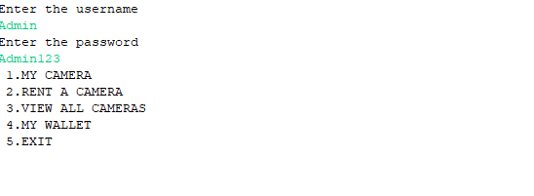

-On selecting different options the output will be look like this.

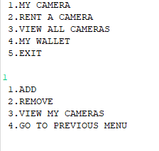

1.Adding a New Camera To List

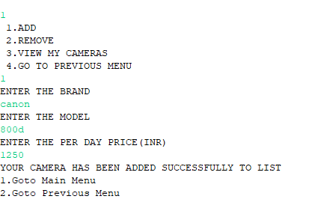

2.Removing the camera based on the cameraId

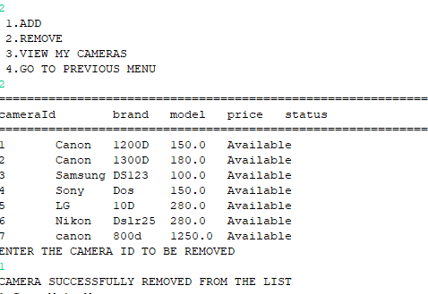

3.Viewing all the cameras in list.

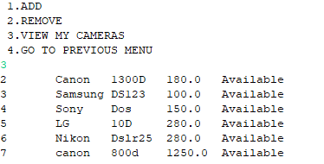

4.Rent a Camera based on the camera Id

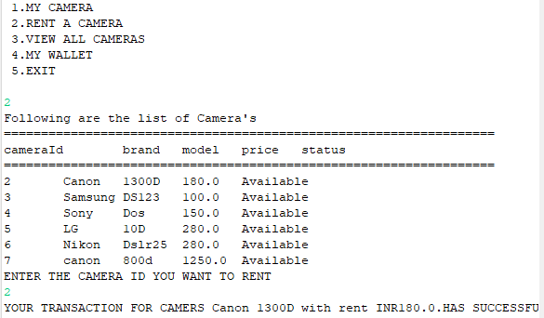

5.Display all the Cameras and it will show as rented after it send for rent.

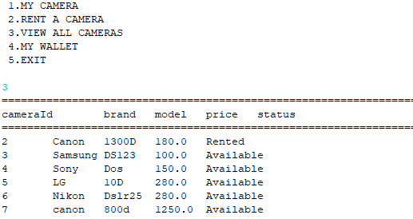

6.To Make Wallet Transactions we select option 4. It will show the wallet balance and helps to add more amount to the wallet.

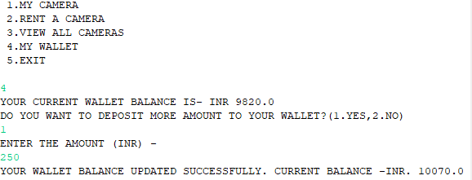

7.Final Optional is to exit from the application with a message displaying over it.

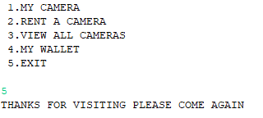

Sprint Planning.

-It took almost 9 hrs to complete the task.

-For first 4 hrs the first 1 option with 3 sub options i.e ADD,Remove,View Cameras

-Next 5hrs for setting remaining options.